

**How to Opt In for Emergency Text Messages**

The Fox Point Bayside School District is happy to announce that we are able to send **Text** messages through Infinite Campus to our district families. This path of communication is in addition to sending IC Campus Messengers as email messages, ICinbox messages and voice (phone call) messages.

Each type of communication will be used for the following reasons:

| **Purpose of Communication** | **Email** | **IC Inbox** | **Voice** | **Text** |
| --- | --- | --- | --- | --- |
| General Information, Upcoming Events, Friday Folder, Daily Communication Folder, etc. |  |  |  |  |
| School Closing/Inclement Weather/ Emergency |  |  |  |  |
| Urgent Incident Notification **including**:   * Bus cancellations or lengthy delays * Cancellations of school sponsored events - Athletics and after school activities * Urgent parent traffic disruption (construction related) |  |  |  |  |

All Campus Messengers that are Emergency Messages (including School Closing/Inclement Weather notices) will also now be sent as Text Messages (in addition to Voice and Email), **but only if the parent/guardian turns on Texting service in Infinite Campus.**

**Please follow the directions below if you would like to receive emergency text messages.** Data rates may apply.

**How to Turn on Text Messaging Directions:**

**If you would like to receive Text Messages**, you will need to complete ALL of the following steps below and/ or **watch the first 2:35 of** [**this tutorial video**](https://kb.infinitecampus.com/help/update-contact-and-demographic-information-video).

1. Text the word **START** to **91201**. When you receive a reply, Text **YES** to confirm that you would like to receive Text messages from the district.
2. Login to your [**Campus Parent Portal**](https://foxpointwi.infinitecampus.org/campus/portal/foxpoint.jsp)**.** 
   * *\*Note: If you have forgotten your username and/or password, use the Forgot Username or Forgot Password links. If you tried these and have not received an email to help you, please email* [*ICHelp@foxbay.org*](mailto:ICHelp@foxbay.org) *for more assistance.*



1. Click on the **Person symbol** in the upper right corner
2. Click on **Settings**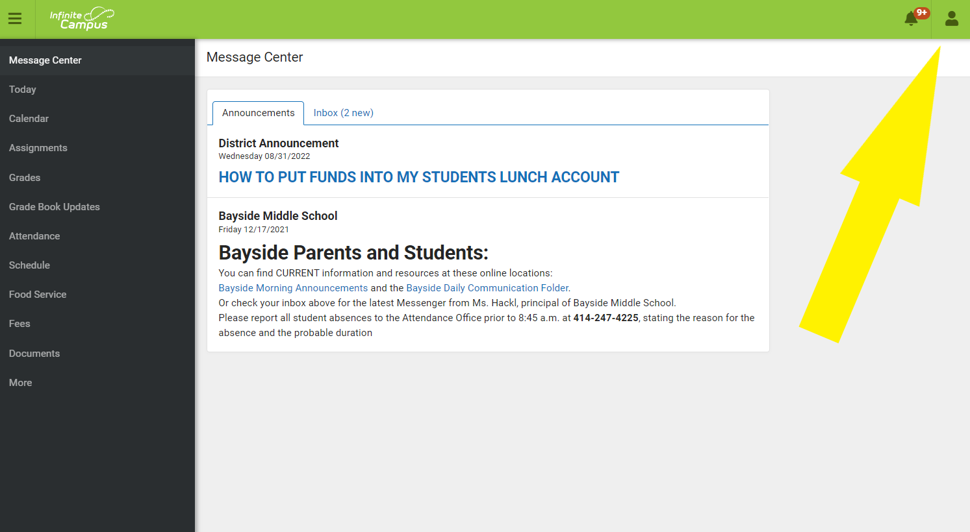

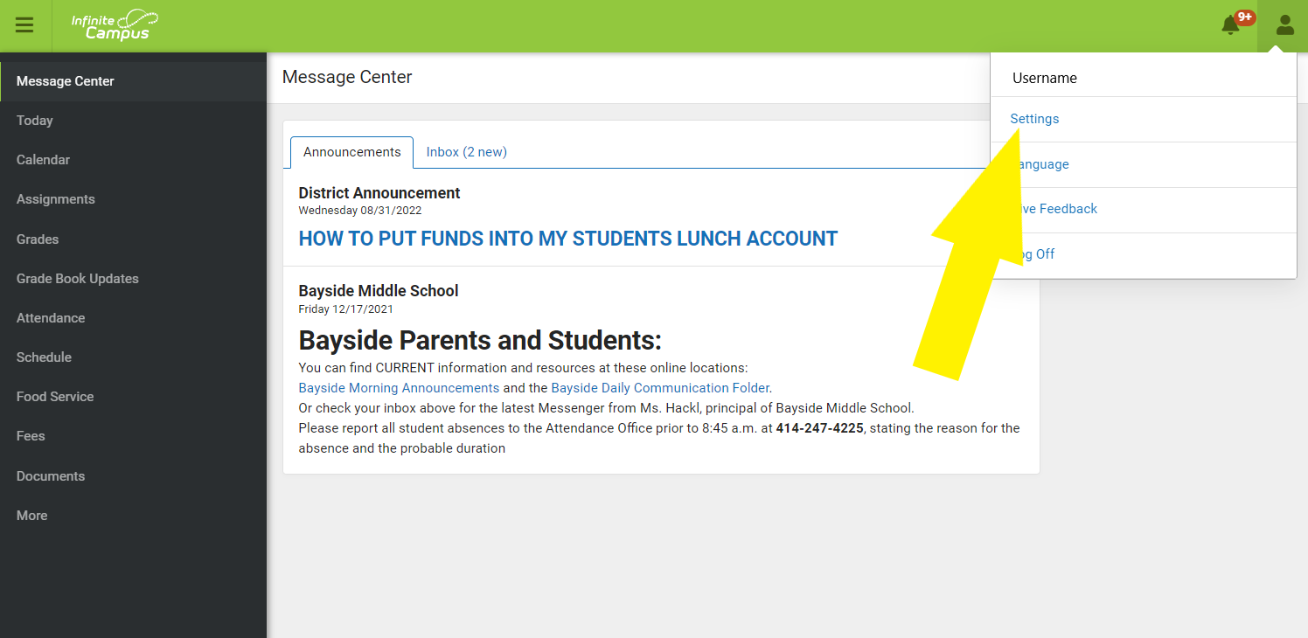

5. Select **Contact Preferences**

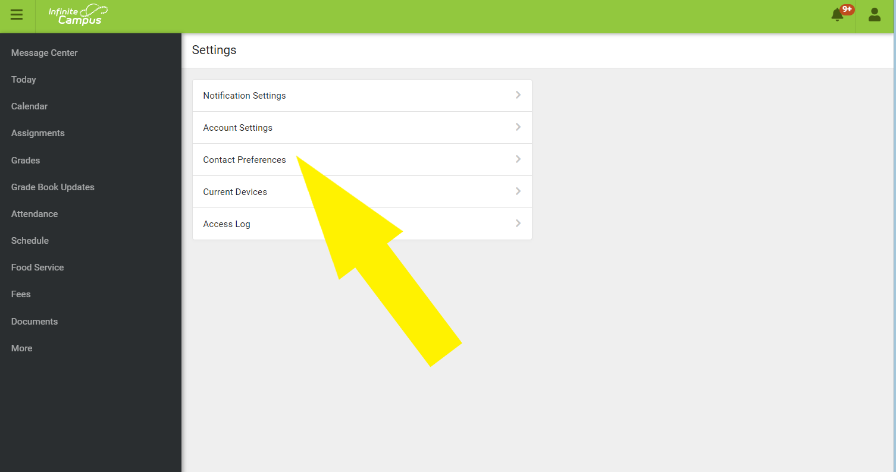

**6. Scroll down to see the table of contact options**

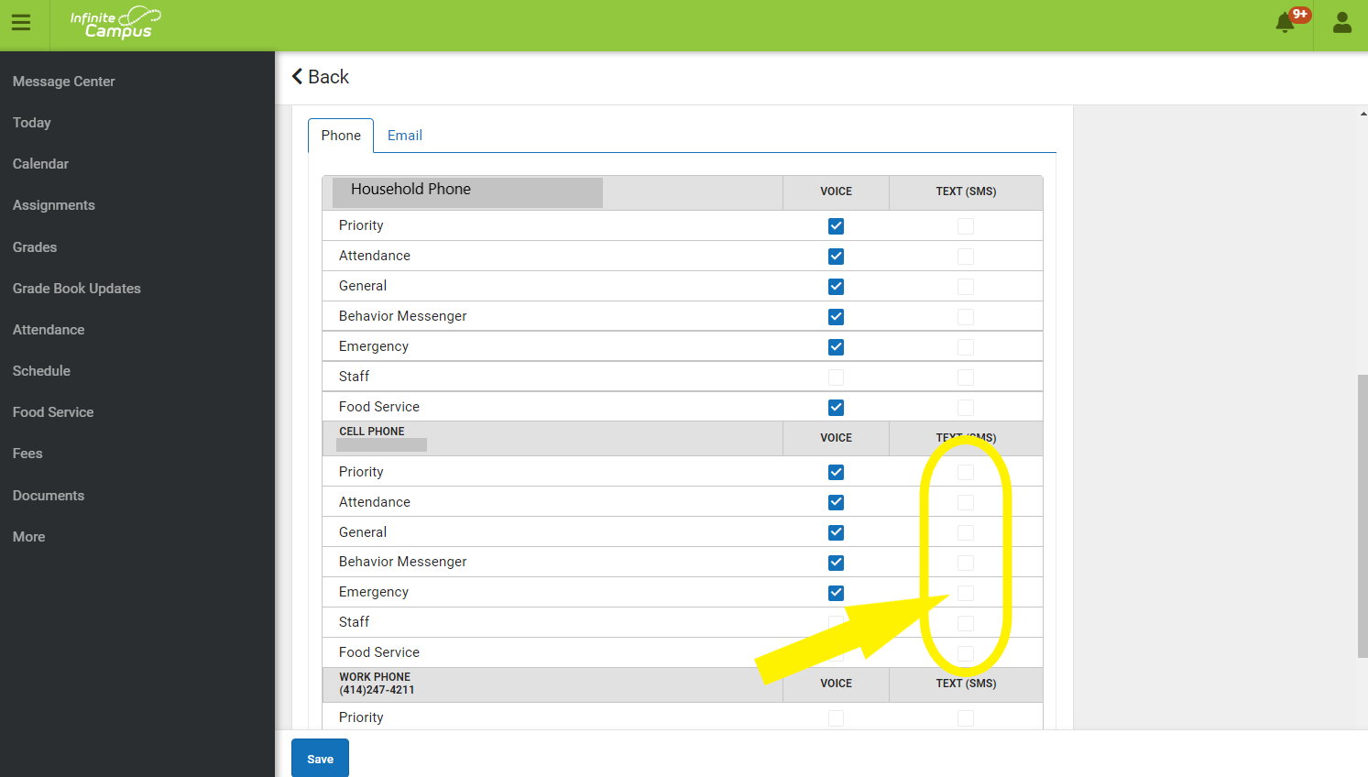

7. **Click the Checkbox under Text (SMS) by every type of message for which you are willing to receive a Text message.**

We are currently only using texting for Emergency messages, School Closings, Inclement Weather, and Urgent Incident notifications (see table on first page for detail). Select any other categories to indicate your preferences for potential expansion of text messaging in the future.

**IMPORTANT:** In order to receive Emergency messages (either Voice or Text), **you must have the Emergency checkbox marked on the phones designated to receive these calls.**

8. Click **Save.** You will now receive text messages from Infinite Campus.

9. Finally, if you haven’t already done so, Text the word **START** to **91201**. When you receive a reply, Text **YES** to confirm that you would like to receive Text messages from the district.

**Please Note:**

* ***If you text the word START to 91201*** ***and never receive the response text despite having adequate reception***, you will need to call your cell phone carrier to see whether Premium Messaging is blocked. If Premium Messaging is blocked, it must be unblocked to receive texts from the district.
* ***Additional charges may apply to the delivery of text messages.*** Contacts who want to receive text messages should be aware that phone service providers may charge extra for texting services. Infinite Campus and the Fox Point Bayside School District are not responsible for text message charges.
* ***If you wish to stop receiving text messages,*** you can text STOP to 91201. This results in your number receiving no further text messages from Campus, even if you have the Text option marked on your Contact Preferences.
* ***While you are adding Text to your contact Preferences,*** you may want to update your other preferences for Voice calls or Email (for email you’ll need to click on the Email tab). [Explanation of Checkboxes in Contact Preferences](https://docs.google.com/document/d/1vWE6OtchOxGtophbWCy_3KgmO1IRagFg0iFHelPEgXY/edit?usp=sharing) will explain what each checkbox will mean to the system.